Chapter 6
Experimental Design and Evaluation
This chapter presents the experimental design, evaluation framework, metrics, baselines, ablations, and statistical methodology used to assess the Quiz Generation Subsystem (Part B) of the AI Tutor. All quantitative outcomes and significance results are deferred to Chapter 7: Results and Discussion.

6.1 Experimental Setup

6.1.1 Hardware Environment
Training, distillation, and evaluation were executed on Kaggle Notebooks, providing a reproducible compute substrate with fixed driver versions and accelerator topology that eliminates local hardware variance across iterations.
Table 6.1 — Hardware Specifications
Component | Specification
Execution Platform | Kaggle Online Notebooks
GPU (Training & Distillation) | 2 × NVIDIA Tesla T4 (15–16 GB VRAM each)
CPU | Intel Xeon (4 vCPU, Kaggle-allocated)
System RAM | 29 GB
Working Storage | 73 GB ephemeral SSD scratch
Training Precision | Mixed precision (fp16) with LoRA adapters
Inference (Teacher) | Google AI Studio / Gemini API (remote)
Inference (Student) | Same Kaggle T4 runtime for evaluation parity

6.1.2 Software Environment
The stack is version-pinned per notebook to guarantee reproducibility across the eight distillation iterations. The student is built on HuggingFace; the teacher is accessed via the Gemini API; and semantic grounding uses the BGE-Large embedding family.
Table 6.2 — Software Stack
Layer | Tool / Library | Role
Runtime | Kaggle | Containerised online execution
Language | Python 3.10 | Notebook and library substrate
Modelling | PyTorch 2.x | Tensor backend for training/inference
Transformers | HuggingFace transformers, accelerate | Student loading, generation, training loop
Fine-Tuning | PEFT (LoRA), TRL (SFTTrainer) | Parameter-efficient supervised fine-tuning
Quantisation | bitsandbytes | 4-/8-bit loading for memory efficiency
Teacher Access | google-generativeai SDK | Gemini 2.5 Flash Lite client
Embeddings | sentence-transformers (BGE-Large-EN) | Semantic grounding for S5
Evaluation | numpy, pandas, scipy.stats, scikit-learn | Metric computation, statistical tests
Visualisation | matplotlib, seaborn | V1–V12 evaluation views
Schema Validation | jsonschema, pydantic | Structural and field validation

6.1.3 Reproducibility Configuration
Reproducibility is enforced through: (i) a global random seed applied to python.random, numpy and torch (CPU/CUDA) RNGs and re-applied prior to dataset shuffling and trainer instantiation; (ii) cuDNN deterministic mode with non-deterministic kernels avoided in evaluation paths, and fixed decoding hyperparameters (temperature, top-p, max-new-tokens) shared across teacher, base and fine-tuned student; (iii) per-notebook environment pinning with explicit version constraints on top of the Kaggle frozen base image; and (iv) dataset versioning—the teacher generation corpus, S5-passed corpus and final SFT corpus are persisted as JSONL artefacts (teacher_outputs.jsonl, passed_mcqs.jsonl, selected_subset_v3.jsonl) and reused unchanged to isolate training-time effects.
Each iteration is stored under a dedicated Version_1…Version_8 directory containing the notebook, model outputs, judge scores, training plots and evaluation views. LoRA adapter checkpoints are saved per version; the final retained adapter corresponds to the best-performing iteration referenced in Chapter 7. Intermediate checkpoints are pruned to conserve storage. A full reproducibility report — including seeds, package manifests and dataset hashes — appears in Appendix B.

6.2 Baselines and Comparative Benchmarks
The design contrasts three model configurations and four pipeline configurations, satisfying KSI-1 by establishing more than two credible baselines rooted in the MCQ Generation Subsystem Technical Reference.
- Teacher — Gemini 2.5 Flash Lite. Upper-bound reference and source of supervisory signal during distillation (dataset construction and quality ceiling).
- Base Student — Qwen2.5-1.5B-Instruct (no adapter). Lower-bound capability of the deployable student; isolates the effect of supervised distillation.
- Fine-Tuned Student — Qwen2.5-1.5B-Instruct + LoRA adapter (best iteration). Deployment candidate; comparison against the teacher quantifies retained quality at compressed scale.
- Validation Layer Disabled vs Enabled. Evaluates the S5 slot-level validation pipeline as a runtime quality gate.
Fairness is enforced by holding the chunk pool, decoding hyperparameters, judge rubric and statistical procedure constant across baselines, so that observed differences are attributable to the configuration under test.
Table 6.3 — Baseline and Benchmark Configurations
Configuration | Purpose | Enabled | Disabled | Objective
B1: Teacher (Gemini 2.5 Flash Lite) | Upper-bound reference | Teacher API, S5 | Student model | Quality ceiling for MCQs
B2: Base Student (Qwen 2.5-1.5B) | Lower-bound capability | Student inference | LoRA, distillation | Untrained baseline
B3: Fine-Tuned Student | Deployment candidate | Student + LoRA, S5 | — | Quality after distillation
B4: Pipeline w/o Validation | Isolate S5 contribution | Generation only | S5, regeneration | Effect of validation gate
B5: Pipeline w/o Regeneration | Isolate regeneration | Generation + S5 | Regeneration loop | Effect of bounded re-prompting

6.3 Evaluation Framework

6.3.1 Overview
The framework is organised in three complementary tiers. Tier 1 is the S5 slot-level validation pipeline that gates every MCQ on structural, semantic and pedagogical criteria. Tier 2 is an LLM-as-Judge protocol scoring all three model variants along six pedagogical dimensions. Tier 3 is a statistical suite aggregating judge scores into composite metrics, contrasting distributions and performing significance tests. Together they cover automated checks, semantic grounding, educational quality, distillation fidelity and operational behaviour, satisfying KSI-3.
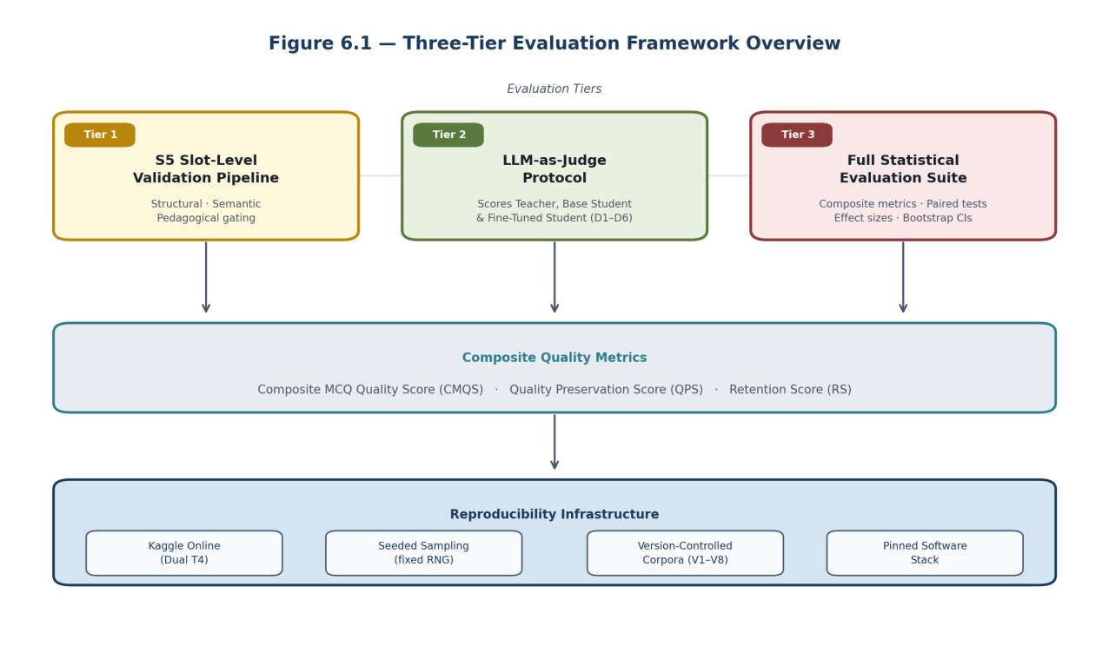
Figure 6.1 — Three-tier evaluation framework overview.

6.3.2 Per-Model Evaluation Methodology
Teacher (Gemini 2.5 Flash Lite) is evaluated to characterise the quality ceiling and validate the supervisory signal. The S5 pipeline is applied to teacher outputs (yielding the curated SFT corpus) and a fixed sample is then scored by the LLM judge. Metrics include structural validity, semantic grounding, Bloom alignment, distractor quality and the composite MCQ Quality Score (CMQS).
Base Student (Qwen2.5-1.5B-Instruct, no adapter) serves as the lower-bound baseline under the same prompt template and chunk pool as the teacher and fine-tuned student. No quality gate or regeneration is applied to its raw outputs, so the unaided capability of the small model is quantified. Metrics are identical to the teacher to enable paired comparisons.
Fine-Tuned Student augments the same backbone with the LoRA adapter trained on the curated SFT corpus and is evaluated under conditions identical to the base student (prompts, decoding, chunks, rubric, statistics). This isolation ensures that any measured B2→B3 shift is attributable to distillation alone.

6.3.3 Comparative Evaluation Design
A controlled paired protocol is used: for every evaluation chunk all three models produce an MCQ, which are then scored by the judge under an identical rubric. Pre- vs post-fine-tuning comparison quantifies the effect of distillation; teacher vs fine-tuned student comparison quantifies retained quality at compressed scale. Fairness is enforced by sharing the chunk pool, fixing decoding hyperparameters, anonymising model identity where appropriate, and using paired within-chunk statistics.
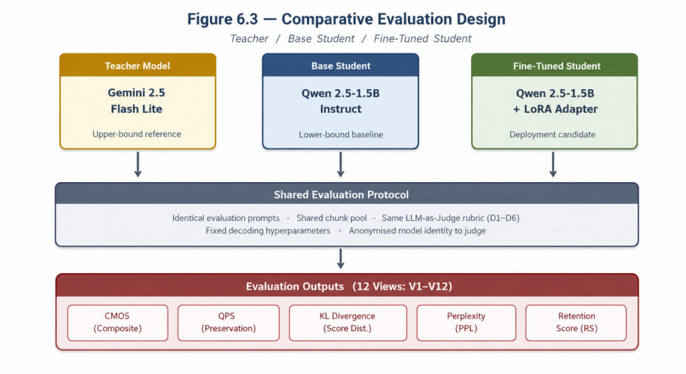
Figure 6.3 — Comparative evaluation across teacher, base student and fine-tuned student.
Table 6.4 — Planned Comparative Evaluations
Comparison | Question Answered | Sample Pairing | Metrics (Ch.7)
Teacher vs Base Student | How much quality does the small model lack initially? | Per-chunk paired | CMQS, D1–D6, QPS
Base vs Fine-Tuned Student | What did distillation contribute? | Per-chunk paired | CMQS, D1–D6, KL, PPL
Teacher vs Fine-Tuned Student | How much teacher quality is retained? | Per-chunk paired | CMQS, QPS, Retention
Pipeline w/ vs w/o S5 | Contribution of the validation gate | Per-MCQ matched | Pass-through yield, CMQS uplift
Pipeline w/ vs w/o Regeneration | Contribution of bounded regeneration | Per-MCQ matched | Final-pass yield, CMQS uplift

6.4 Evaluation Metrics
A multi-metric design is adopted: no single score is conclusive. Structural, semantic, pedagogical, distillation and operational metrics are reported jointly, satisfying KSI-3.

6.4.1 Structural
JSON Parse Rate (JPR) — proportion of outputs that parse as valid JSON without repair; a generator that cannot emit a parseable object cannot be served. Structural Validity Score (SVS) — proportion of parsed outputs that additionally satisfy the schema (required fields, four options, exactly one correct answer index, non-empty rationale).
JPR = N_parsed / N_total ; SVS = N_schema_valid / N_parsed

6.4.2 Educational
Bloom Taxonomy Accuracy — agreement between generator-declared and judge-assigned Bloom level (cognitive-level fidelity). Difficulty Accuracy — agreement between requested and judge-observed difficulty (controllability). Educational Quality Score (CMQS) — weighted aggregate over judge dimensions D1 clarity, D2 correctness, D3 distractor plausibility, D4 cognitive alignment, D5 faithfulness, D6 pedagogical usefulness, each on a 1–5 scale.
BloomAcc = (1/N) · Σ 1[bloom_gen_i = bloom_judge_i]
DiffAcc = (1/N) · Σ 1[difficulty_req_i = difficulty_obs_i]
CMQS = Σ_{i=1..6} w_i · D_i, Σ w_i = 1, D_i ∈ [1, 5]

6.4.3 Semantic
Semantic Similarity — cosine similarity between BGE-Large-EN embeddings of the question stem and source chunk. Chunk Grounding Score (CGS) — indicator (or graded variant) that the correct answer is verifiable from the source chunk; used as a hard gate in S5 stage 3.
cos(q, c) = (e_q · e_c) / (‖e_q‖ · ‖e_c‖)
CGS = 1[answer verifiable from source chunk] (graded: judge chunk_grounding ∈ [1,5])

6.4.4 Distillation
Quality Preservation Score (QPS) — CMQS_student / CMQS_teacher; QPS → 1 indicates full preservation. KL Divergence of judge-score distributions — smaller means the student is closer to the teacher. Perplexity (PPL) — token-level perplexity on a held-out SFT subset as a training-time fidelity signal. Retention Score (RS) — combined indicator trading quality against inference latency.
QPS = CMQS_student / CMQS_teacher
KL(P_T ‖ P_S) = Σ_x P_T(x) · log( P_T(x) / P_S(x) )
PPL(X) = exp( −(1/N) · Σ log p(x_i | x_<i) )
RS = QPS · (latency_teacher / latency_student)

6.4.5 Operational
Throughput — MCQs per minute under fixed decoding. Validation Pass Rate — fraction passing each S5 stage and the overall pipeline. Deduplication Rate — fraction removed by near-duplicate detection.
Throughput = N_MCQ / T_minutes
VPR_s = N_pass_s / N_input_s ; Pipeline yield Y = Π_{s=1..5} VPR_s
DR = N_removed_duplicates / N_candidates

6.4.6 Classification and Regression (Auxiliary)
When Bloom or difficulty labelling is framed as classification, Accuracy, Precision, Recall and F1 are reported per class and macro-averaged. When graded judge scores are treated as ordinal regression targets, MAE and RMSE summarise deviation from reference scores.
Accuracy=(TP+TN)/(TP+TN+FP+FN); Precision=TP/(TP+FP); Recall=TP/(TP+FN); F1=2PR/(P+R)
MAE = (1/N) Σ |ŷ_i − y_i| ; RMSE = √( (1/N) Σ (ŷ_i − y_i)² )

6.5 Ablation Study Design
Ablations isolate the contribution of individual components (satisfying KSI-2). Each contrasts two otherwise-identical configurations differing in exactly one component, using the same chunk pool, decoding hyperparameters and judge rubric.
- A1 — w/o vs w/ S5 Validation. Metrics: SVS, CMQS, D1–D6, yield.
- A2 — w/o vs w/ Bounded Regeneration. Metrics: final-pass yield, CMQS uplift.
- A3 — w/o vs w/ Deduplication. Metrics: deduplication rate, post-FT CMQS.
- A4 — w/o vs w/ Bloom Verification (S5 stage 4). Metrics: Bloom Accuracy, D4.
- A5 — w/o vs w/ LLM-as-Judge in curation loop. Metrics: corpus CMQS, downstream student CMQS.
- A6 — Teacher Output vs Teacher Output + S5. Metrics: CMQS, structural.
- A7 — Fine-Tuned Student vs Fine-Tuned Student + S5 at runtime. Metrics: CMQS, validation yield.
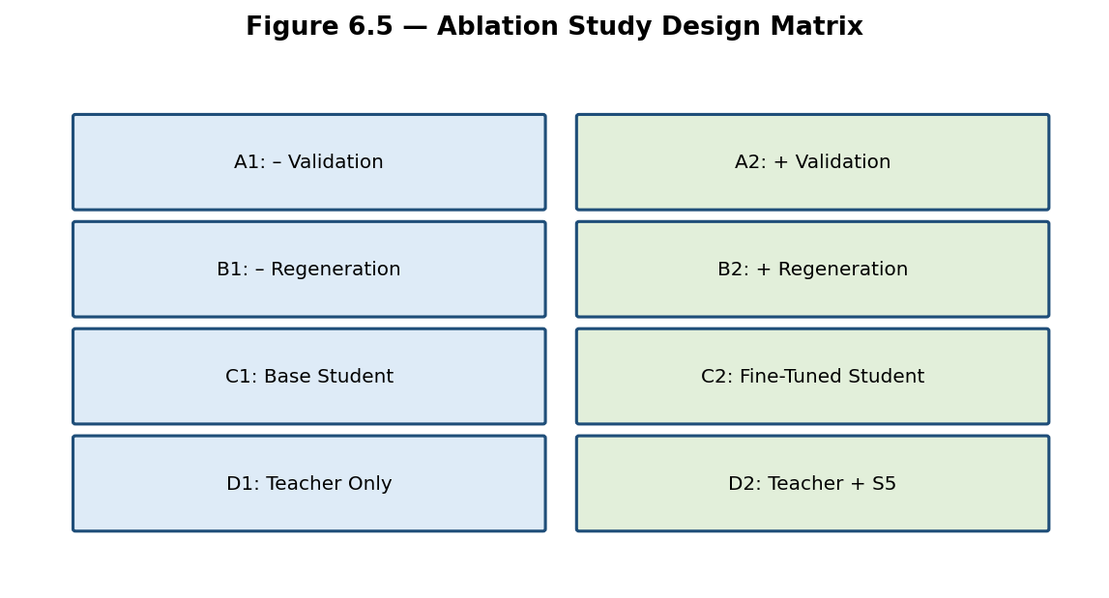
Figure 6.5 — Ablation study design matrix.
Table 6.5 — Ablation Study Configurations
ID | Config A | Config B | Component | Metrics | Objective
A1 | Generation only | Generation + S5 | Validation pipeline | SVS, CMQS, D1–D6, yield | Value of validation gate
A2 | S5 w/o regen | S5 with regen | Bounded regen loop | Final yield, CMQS | Value of re-prompting
A3 | Corpus w/o dedup | Corpus w/ dedup | Deduplication stage | Dedup rate, post-FT CMQS | Diversity control
A4 | S5 w/o Bloom check | S5 w/ Bloom check | S5 stage 4 | Bloom Acc, D4 | Value of Bloom enforcement
A5 | Auto gating only | Auto gating + Judge | LLM-as-Judge curation | Corpus/student CMQS | Value of judge curation
A6 | Teacher raw | Teacher + S5 | Runtime validation | CMQS, SVS | S5 lift on strong generator
A7 | FT student raw | FT student + S5 | Runtime validation | CMQS, yield | S5 lift on distilled generator

6.6 Statistical Significance Testing
Comparisons are accompanied by formal significance tests because score differences may reflect sampling variance. All tests are paired wherever the same chunk yields MCQs from multiple configurations; significance level α = 0.05.
Paired t-test — applied when per-chunk score differences are approximately normal; H0: mean difference is zero.
t = mean(d) / (s_d / √n), d_i = score_A_i − score_B_i
Wilcoxon Signed-Rank — non-parametric alternative for non-normal cases (small samples, ordinal judge scores), reported alongside the t-test for robustness.
W = Σ sign(d_i) · rank(|d_i|)
McNemar — binary outcomes (e.g., S5 pass/fail per item) compared on the same items; H0: equal marginal probabilities.
χ² = (b − c)² / (b + c), b, c = discordant pair counts
Bootstrap 95% CIs on CMQS, QPS and Retention Score, by resampling MCQs with replacement (B = 10,000).
95% CI(θ) = [percentile_2.5(θ*), percentile_97.5(θ*)], B = 10,000
Effect sizes — Cohen’s d for paired continuous comparisons; rank-biserial r alongside Wilcoxon — to contextualise significance with practical magnitude. Numerical p-values, CI bounds and effect sizes are reported in Chapter 7.
Cohen’s d = mean(d) / s_d ; r = 1 − (2·W_−) / (W_+ + W_−)

6.7 Validation Layer Evaluation Design
The five-stage slot-level pipeline (FormatConfig, RelevanceConfig, DistractorConfig, DeduplicationConfig, LLMJudgeConfig) is evaluated both as an offline corpus-curation tool and as an online runtime gate. The stages — Format, Relevance, Distractors, Deduplication and LLM-as-Judge — use BGE-Large-EN-v1.5 for embedding, NLI-deberta-v3-large for distractor paraphrase detection, and an LLM judge (Llama-3.3-70B / GPT-OSS-120B with provider fallback) with overall (≥ 3.5) and chunk-grounding (≥ 3.0) thresholds. Per-stage pass rates and aggregate yield are recorded, following the Validation Layer Workflow in Figure 5.6.
Overall pipeline pass rate: P_pass = Π_{s=1..5} VPR_s
S1 (Format): JSON parses ∧ {A,B,C,D} present ∧ |question|≥15 ∧ |explanation|≥20
S2 (Relevance): cos(e_q, e_chunk) ≥ 0.50 (BGE-Large-EN-v1.5)
S3 (Distractors): rel(D,Q)≥0.12 ∧ cos(D,A)≤0.90 ∧ NLI_entail(D,A)<0.78 for every D
S4 (Dedup): keep if max_{q′ ∈ store} cos(e_q, e_{q′}) ≤ 0.92
S5 (LLM Judge): pass if overall_score ≥ 3.5 ∧ chunk_grounding ≥ 3.0 (Llama-3.3-70B / GPT-OSS-120B)
Table 6.6 — Validation Layer Evaluation Criteria
Stage | Purpose | Criterion | Input → Output | Objective
S1 Format | Validate structure/schema | JSON parses; fields A–D; |Q|≥15; |E|≥20 | Raw text → parsed object | JPR & SVS
S2 Relevance | Topical grounding | cos ≥ 0.5 (BGE-Large-EN-v1.5) | Parsed → schema-valid MCQ | Grounding rate
S3 Distractors | Distractor quality | rel ≥ 0.12, cos ≤ 0.90, NLI < 0.78 | Grounded → distractor-valid MCQ | Distractor plausibility
S4 Dedup | Remove near-duplicates | BGE cosine ≤ 0.92 vs global store | Distractor-valid → unique MCQ | Deduplication yield
S5 LLM Judge | Pedagogical gate | Overall ≥ 3.5 / 5; chunk_grounding ≥ 3.0 / 5 | Unique → final MCQ | Pedagogical quality

6.8 Error Analysis Framework
A structured taxonomy is defined a priori so failures observed in Chapter 7 can be categorised consistently. Errors are detected automatically via S5 and the judge rubric and, when ambiguous, by manual inspection of sampled items.
Table 6.8 — Error Category Taxonomy
Error Type | Description | Impact | Example | Detection
Structural | Output unparseable / schema-violating | Cannot be served | Missing options field | S1 Format
Bloom Misclassification | Declared ≠ verified Bloom level | Pedagogical mismatch | "Analyse" item that only recalls | S4 + judge D4
Difficulty Misclassification | Requested ≠ observed difficulty | Wrong learner targeting | "Hard" item with trivial answer | Judge dimension
Distractor Weakness | Implausible or duplicated distractors | Easy to game | Three near-identical options | S5 + judge D3
Duplicate Questions | Near-duplicate of an existing MCQ | Corpus bias | Paraphrase of prior item | Deduplication module
Semantic Irrelevance | MCQ does not pertain to source chunk | Off-topic | Item about unrelated topic | S3 + judge D5
Grounding Failure | Correct answer not verifiable from chunk | Unanswerable | Requires external knowledge | S3
Hallucinated Content | Fabricated facts in stem or rationale | Misinformation | False attribution | Judge D5
Ambiguous Questions | Multiple defensible answers | Unfair item | Two correct options | Judge D2 + manual
Errors are tracked per stage and per dimension across all baselines, enabling per-component diagnostics in Chapter 7.

6.9 Threats to Validity
Internal validity — The LLM judge introduces evaluator bias as it is itself an LM. Mitigation: a fixed rubric, anonymised model identity where possible, dimension-level scoring, and triangulation with non-judge structural and semantic metrics.
External validity — The SFT corpus is drawn from a specific course-material domain; cross-domain generalisation is not directly demonstrated. Mitigation: Bloom and difficulty balancing, broad chunk coverage, and an explicit deferral of domain transfer to future work.
Construct validity — CMQS aggregates six dimensions with fixed weights; alternative weightings could change orderings. Mitigation: all six dimensions are reported separately so conclusions do not rest on the aggregate alone.
Conclusion validity — Significance tests assume independence between paired chunks, approximately satisfied by sampling from distinct passages. Mitigation: paired statistics with bootstrap CIs and effect-size reporting reduce the risk of overstating differences.

6.10 Chapter Summary
This chapter specified the experimental setup, baselines, three-tier evaluation framework, metric suite, ablation design and statistical testing methodology used to assess the Quiz Generation Subsystem. The hardware and software environment were pinned to the Kaggle runtime with dual Tesla T4 GPUs to guarantee reproducibility across eight distillation iterations. Five baselines span the teacher, the base student, the fine-tuned student, and the validation-disabled and regeneration-disabled pipelines. The metric suite combines structural, semantic, educational, distillation and operational measures so no single number drives conclusions, and seven ablations isolate the contribution of individual components. Statistical comparisons use paired t-tests, Wilcoxon signed-rank, McNemar, bootstrap CIs and Cohen’s d. Validity threats were enumerated and mitigated. The experimental outcomes, comparative results, ablation findings and statistical conclusions are presented in Chapter 7: Results and Discussion.

